APPLICATION FOR DEVELOPMENT APPROVAL  Public Consultation Form | 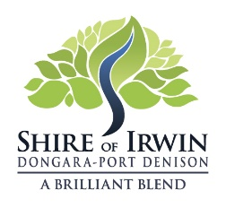

PROPOSED DEVELOPMENT (Ref: P24-22)
Proposed Commercial Vehicle (Use not Listed)
Located on Lot 342 (No. 151) Fane Road, Bonniefield

YOUR CONTACT DETAILS
Name:
Organisation/business (if applicable):
Email Address:
Postal Address:
Phone:
Signature: | Date:

YOUR SUBMISSION
Support Object Indifferent
Any comments you wish to make?
___________________________________________________________________________________

___________________________________________________________________________________

___________________________________________________________________________________

___________________________________________________________________________________

___________________________________________________________________________________

___________________________________________________________________________________

___________________________________________________________________________________

___________________________________________________________________________________

___________________________________________________________________________________

___________________________________________________________________________________

Do you wish to be informed of the outcome (your contact details must be provided)?

YES please NO thank you

Please note the closing date for submissions is: Friday 24th May 2024

Email to: reception@irwin.wa.gov.au
Post to: PMB 21 Dongara WA 6525
Deliver to: Administration Building 11-13 Waldeck Street, Dongara

